**Group 13**

37 Mikil Lalwani

56 Nilay Pophalkar

58 Sanskruti Punyarthi

61 Shree Samal

**CA3 - Assignment 3 :**

**Implement Edge to cloud Protocols (MQTT and COAP) using a dummy data set.**

**MQTT**

**Step 1:** Search for IOT Core

**Step 2:** Create a policy add add policy rule with

**Policy effect = allow**

**Policy action = \***

**Policy Resource = \***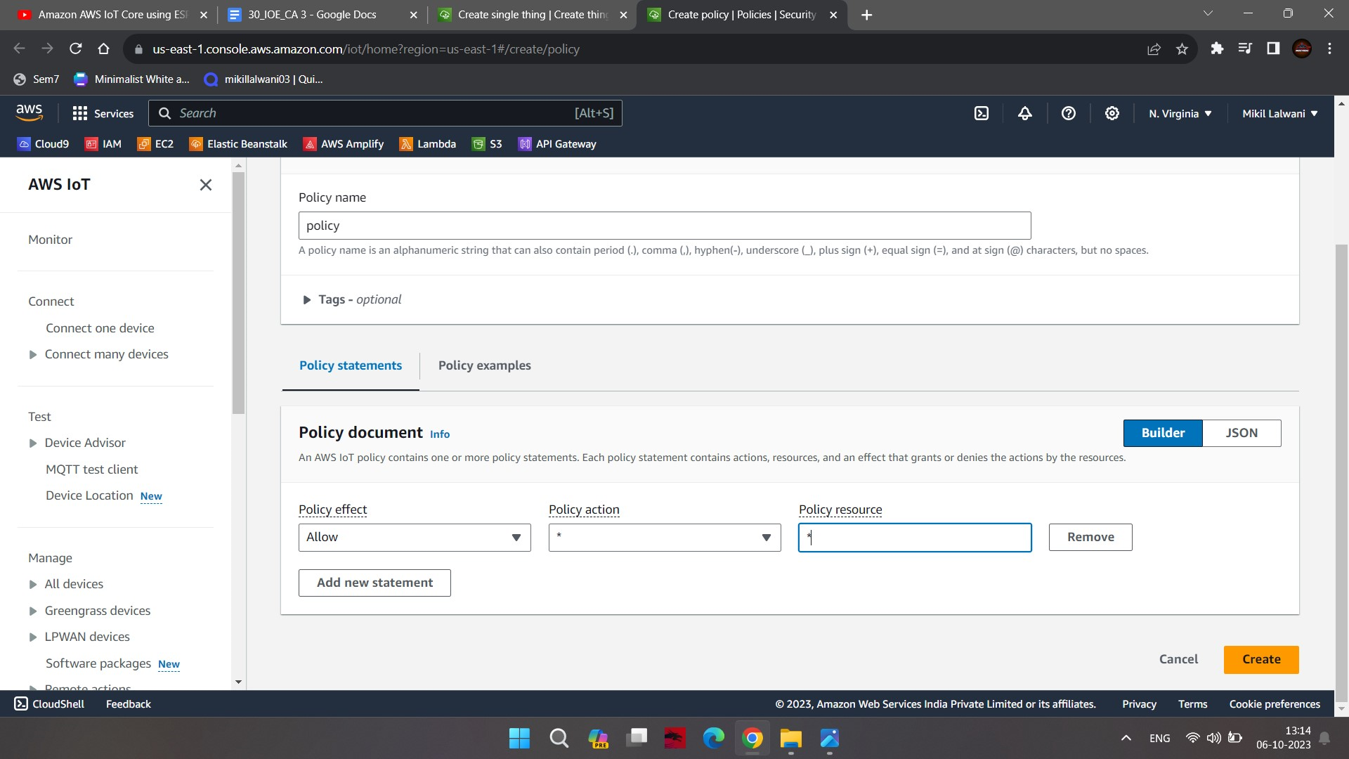

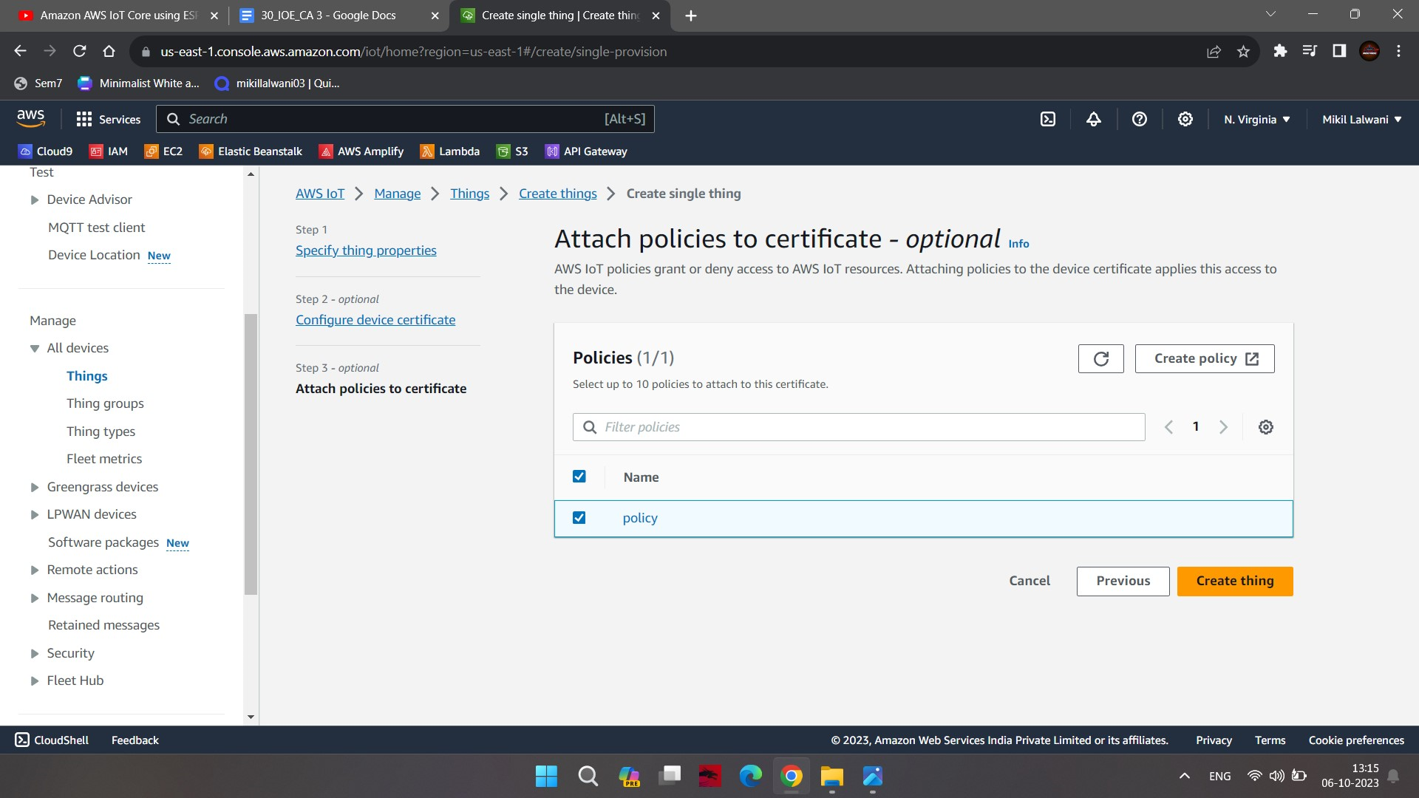

**Step 3:** Click on create thing and add the thing name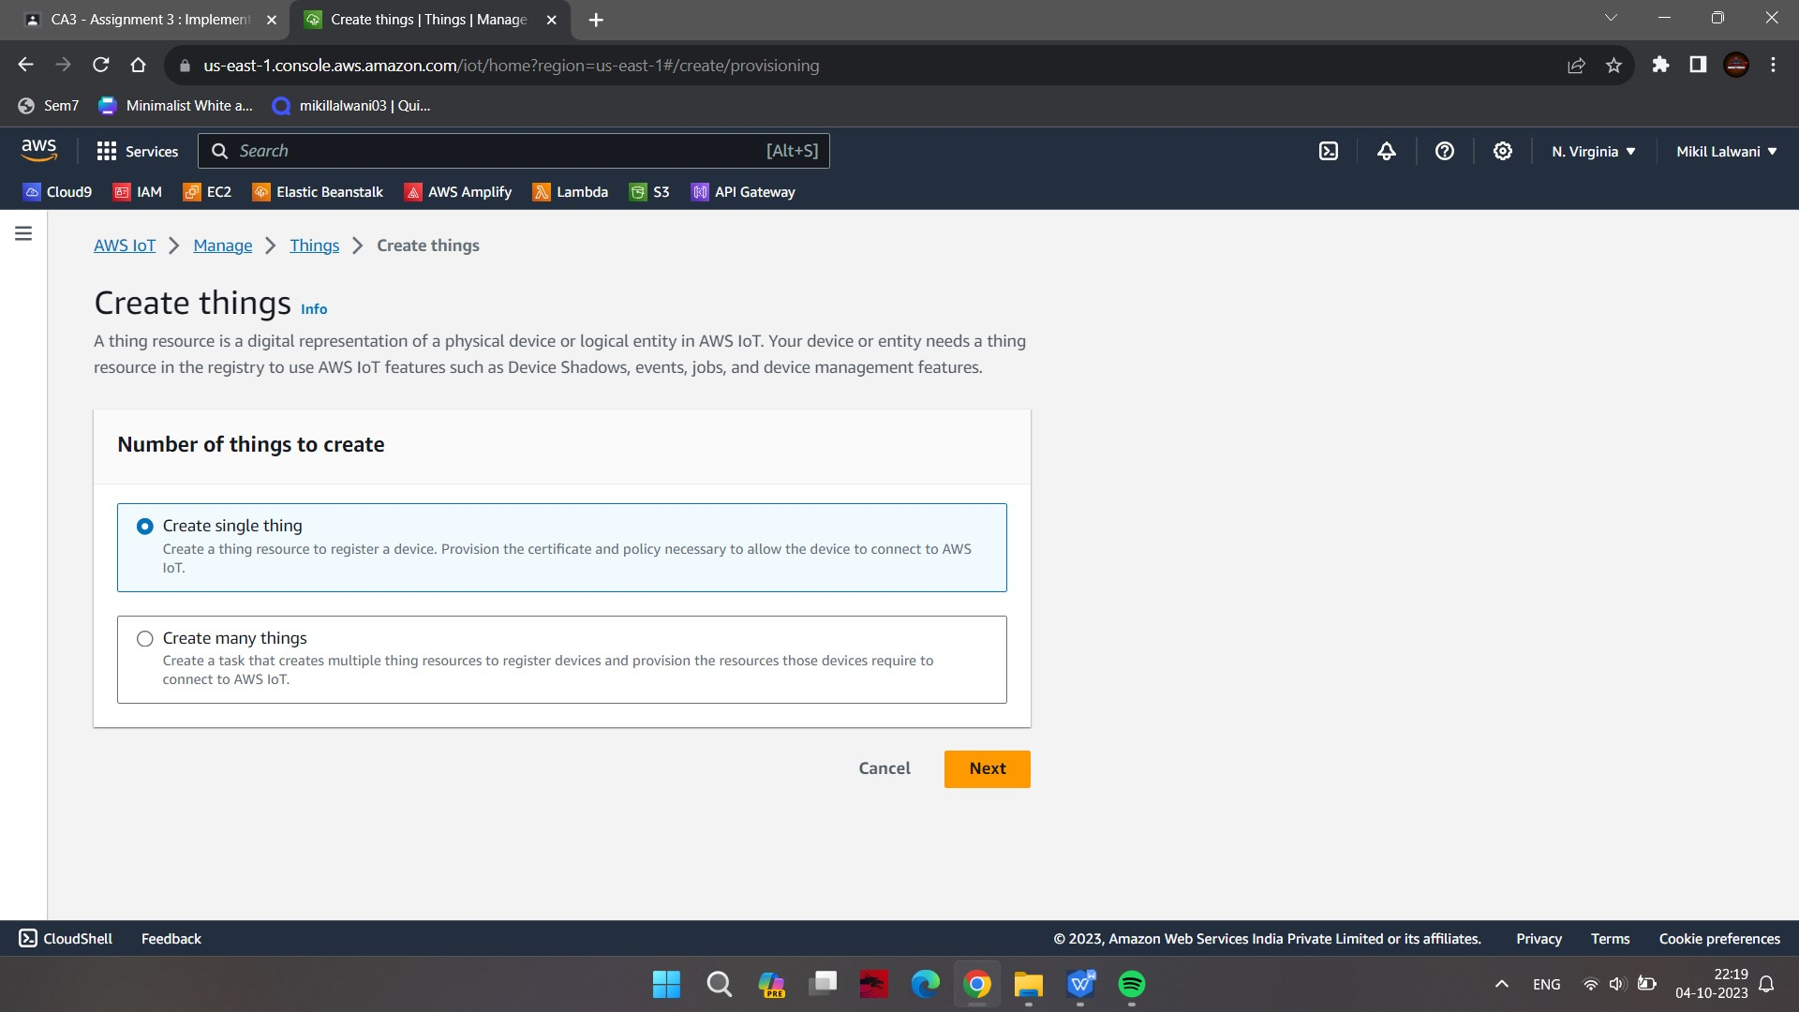

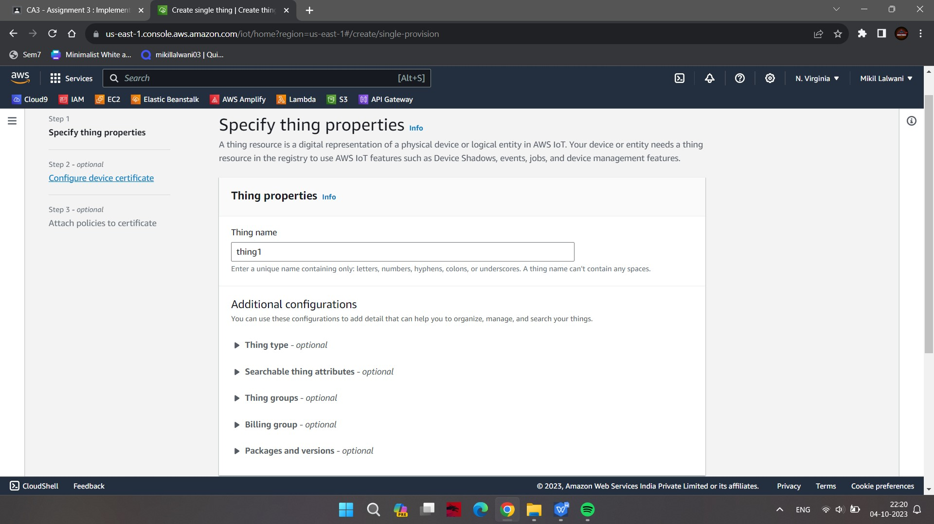

**Step 4:** Click on auto-generate a certificate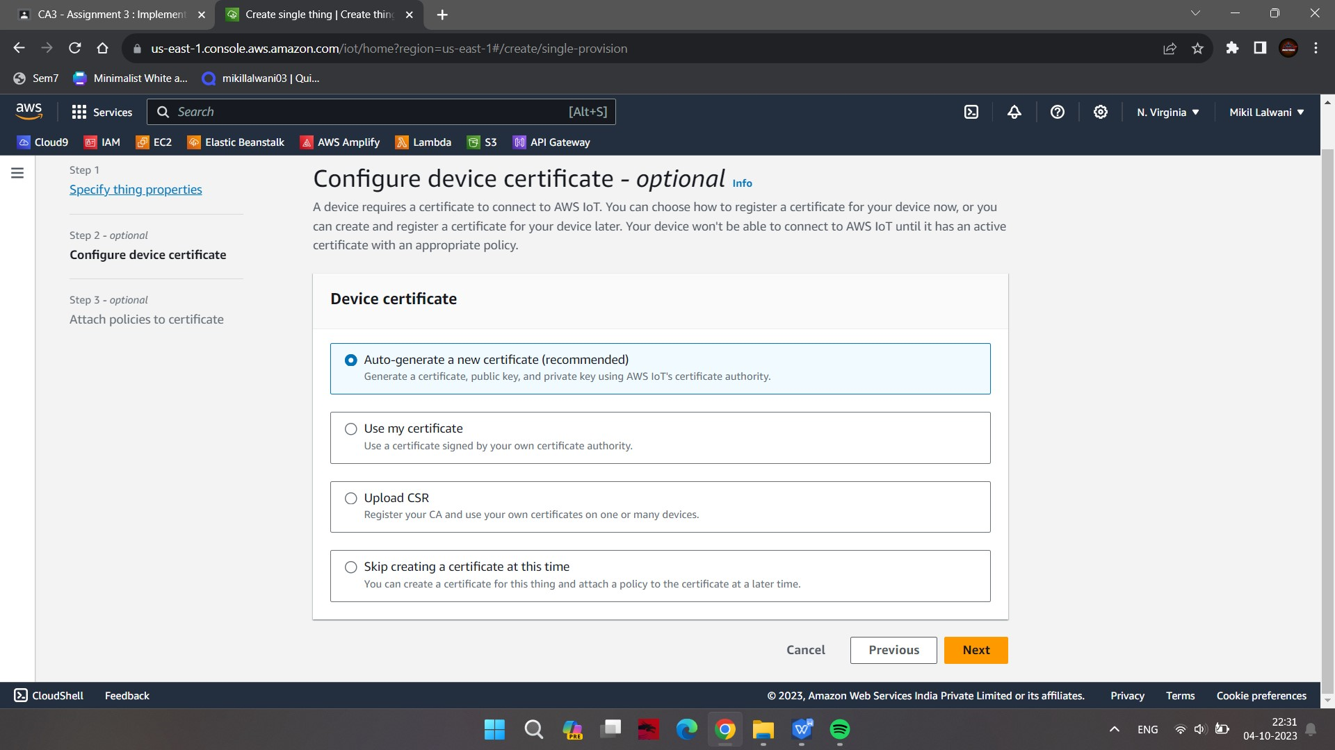

**Step 5:** Attach policy and click on create thing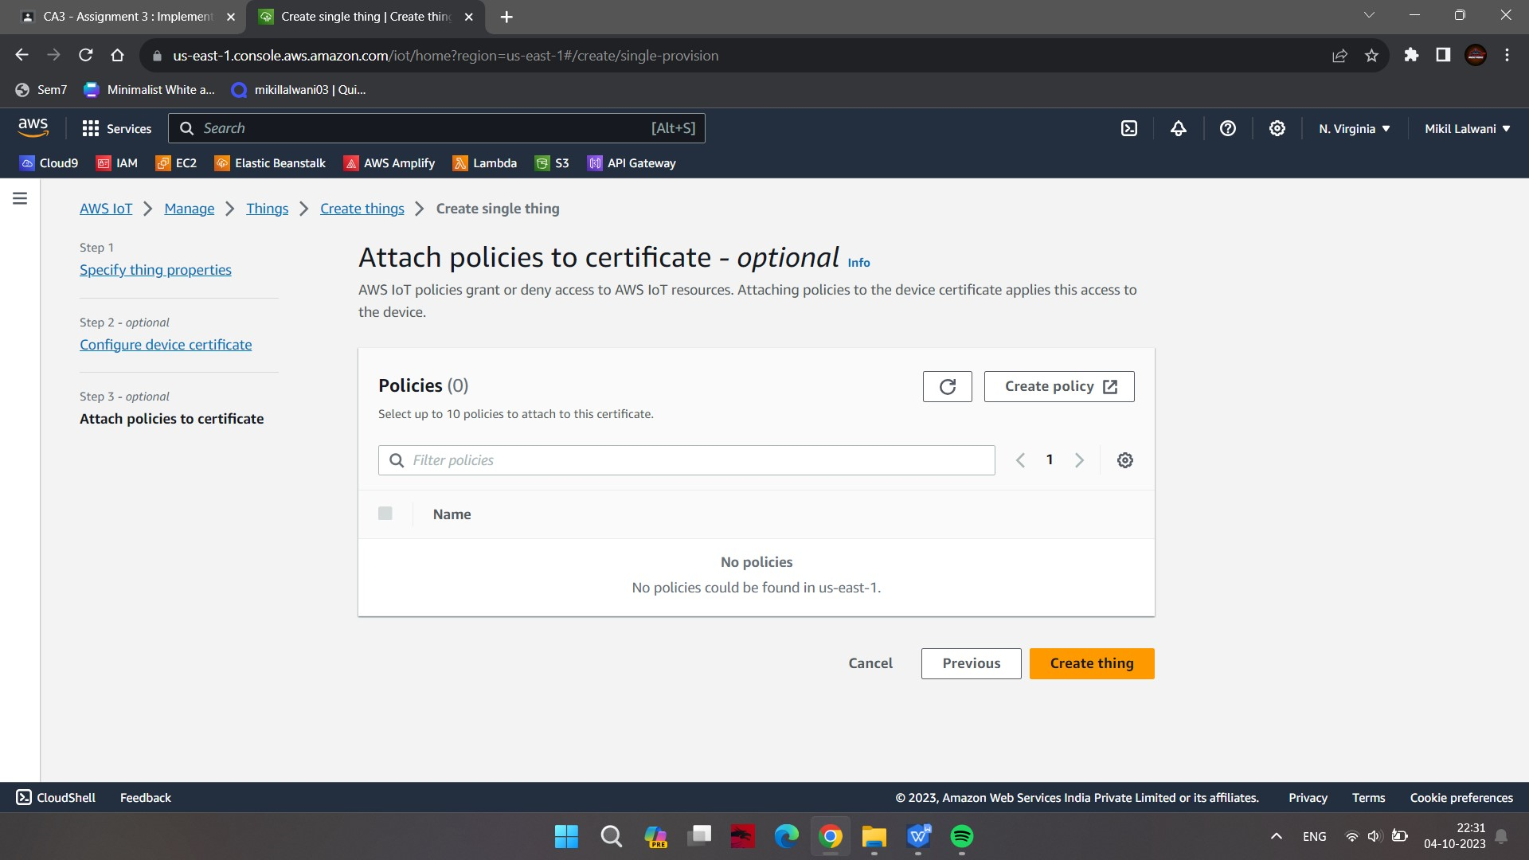



**Step 6:** Download all certificates and keys at the same location

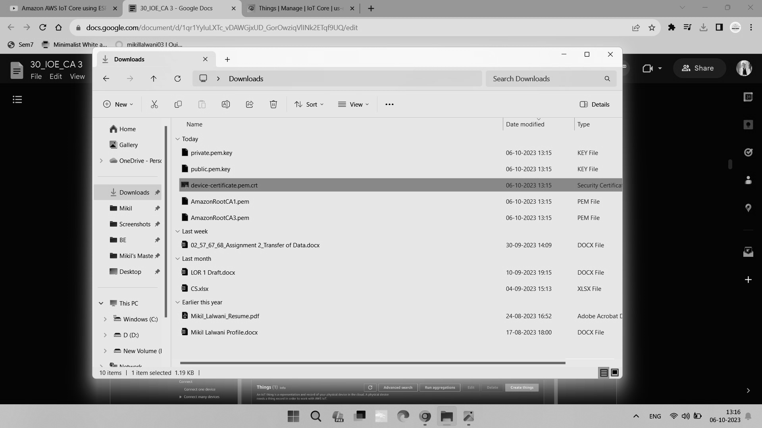

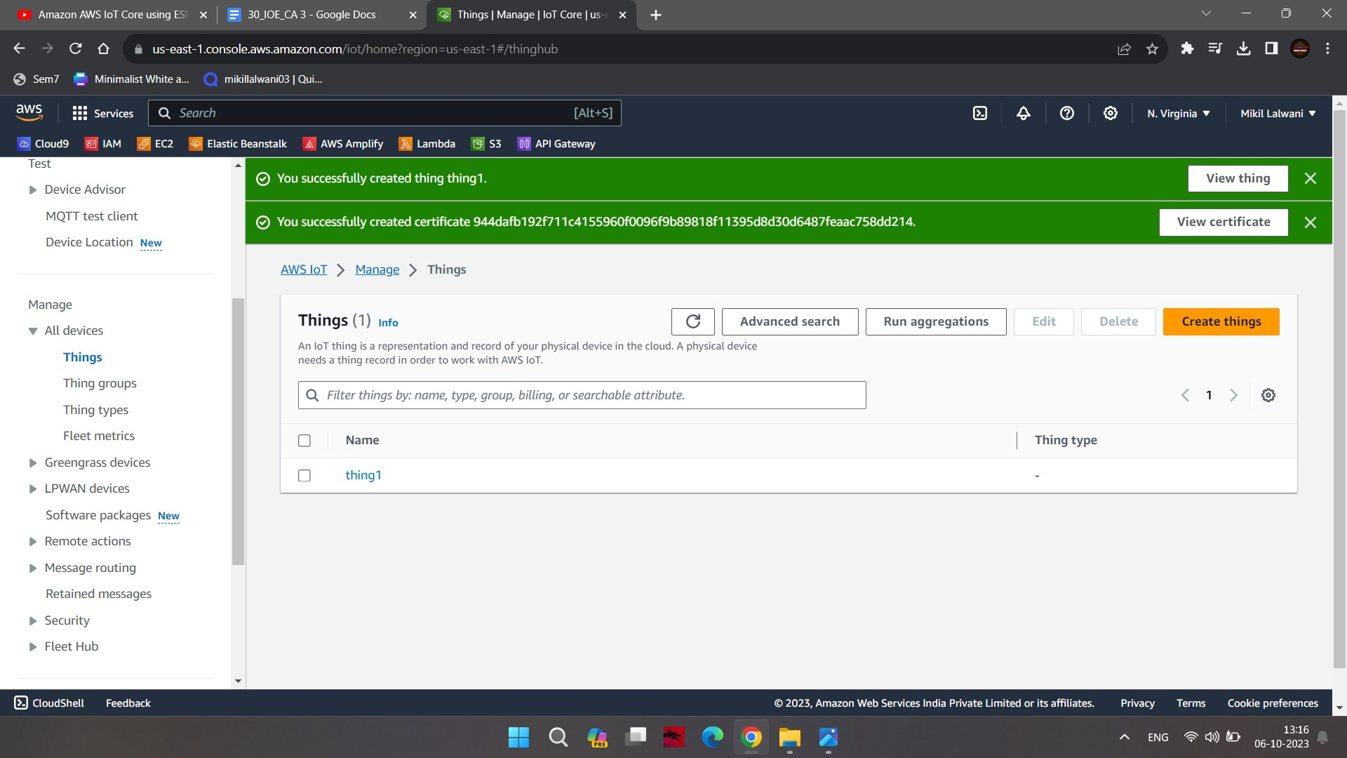

**Step 7:** Clone AWS-MQTT-SDK git repo using the below link in the same folder where you have downloaded the keys and certificate

*-git clone https://github.com/aws/aws-iot-device-sdk-python.git*

**Step 8:** After cloning Run below commands

*-cd aws-iot-device-sdk-python*

*-python setup.py install (2)*

**Step 9:** In main directory save two codes one to publish message to MQTT server and one to subscribe

**Publish.py**

from AWSIoTPythonSDK.MQTTLib import AWSIoTMQTTClient

import sys

myMQTTClient = AWSIoTMQTTClient("thing1") #Enter your things name

myMQTTClient.configureEndpoint("a1ek9vqv3jnbud-ats.iot.us-east-1.amazonaws.com", 8883)

myMQTTClient.configureCredentials("./AmazonRootCA1.pem","./private.pem.key", "./device-certificate.pem.crt")

myMQTTClient.connect()

print("Client Connected")

msg = "Sample data from the device"

topic = "general/inbound"

myMQTTClient.publish(topic, msg, 0)

print("Message Sent")

myMQTTClient.disconnect()

print("Client Disconnected")

**Subscribe.py**

import time

def customCallback(client,userdata,message):

print("callback came...")

print(message.payload)

from AWSIoTPythonSDK.MQTTLib import AWSIoTMQTTClient

myMQTTClient = AWSIoTMQTTClient("thing1")

myMQTTClient.configureEndpoint("a1ek9vqv3jnbud-ats.iot.us-east-1.amazonaws.com", 8883)

myMQTTClient.configureCredentials("./AmazonRootCA1.pem","./private.pem.key", "./device-certificate.pem.crt")

myMQTTClient.connect()

print("Client Connected")

myMQTTClient.subscribe("general/outbound", 1, customCallback)

print('waiting for the callback. Click to conntinue...')

x = input()

myMQTTClient.unsubscribe("general/outbound")

print("Client unsubscribed")

myMQTTClient.disconnect()

print("Client Disconnected")

**Step 10:** In both of above codes replace endpoint with your MQTT test client endpoint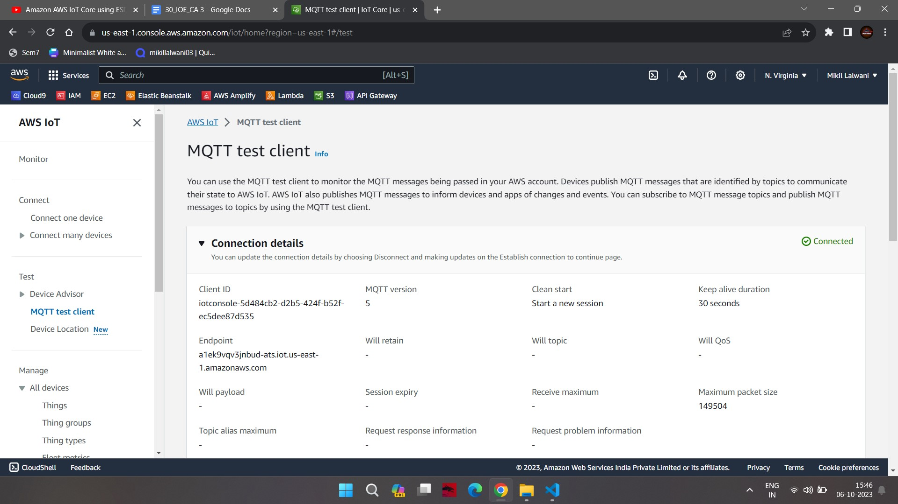

**Step 11:** In MQTT go to Subscribe to a topic and type ‘general/inbound’ and click subscribe don’t close this page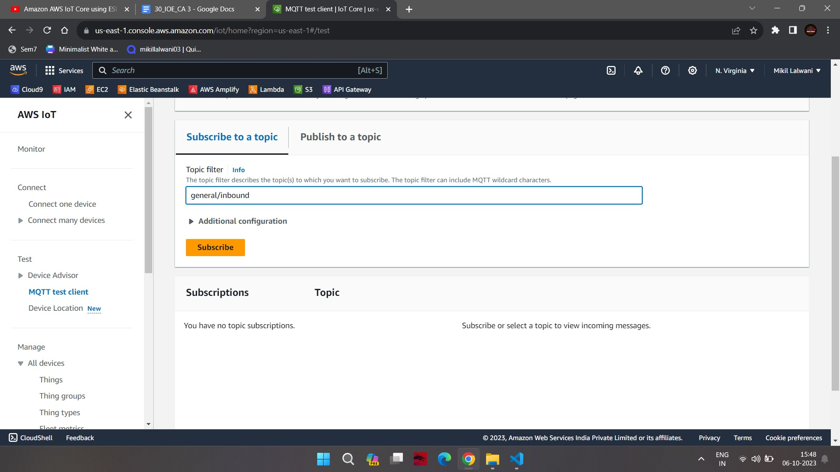**Step 12:** After that run publish.py and go to subscribe page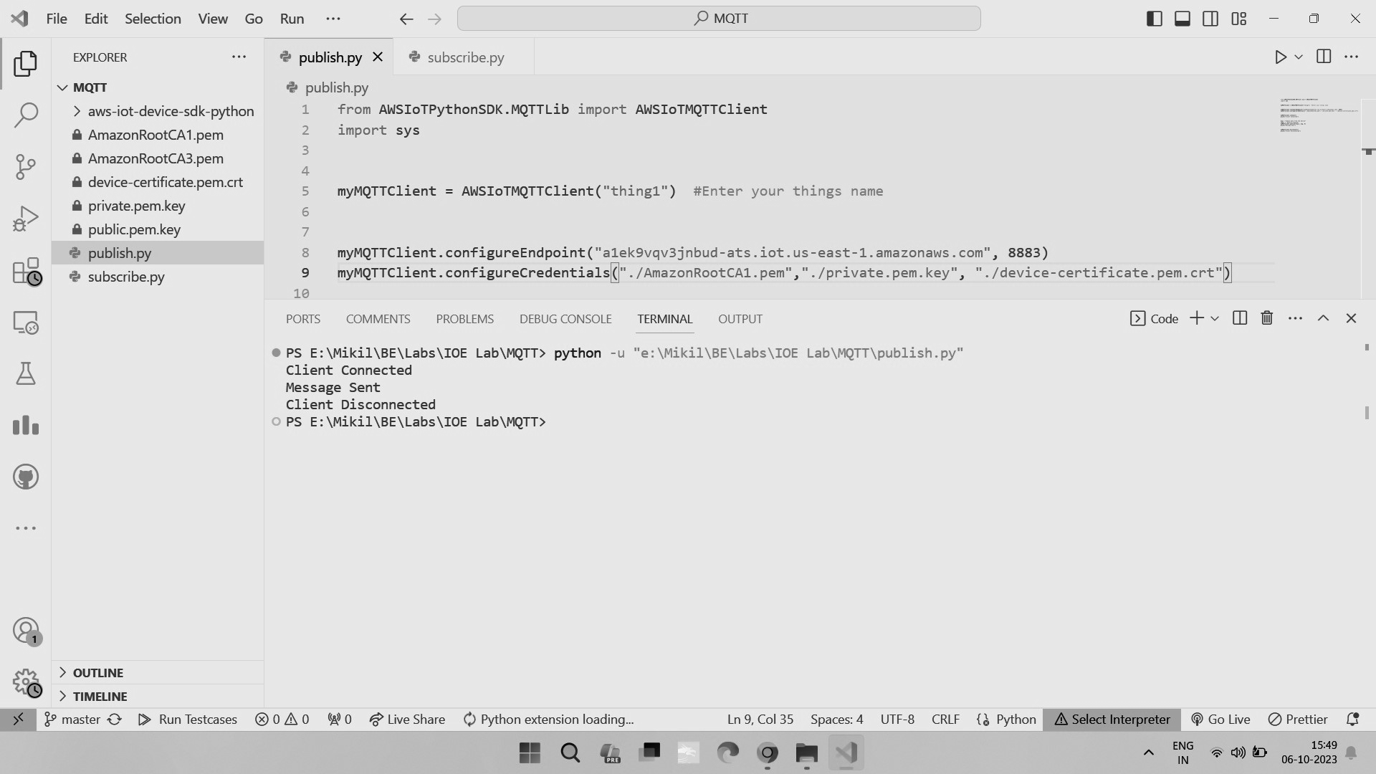

**Step 13:** You can see message on subscribe page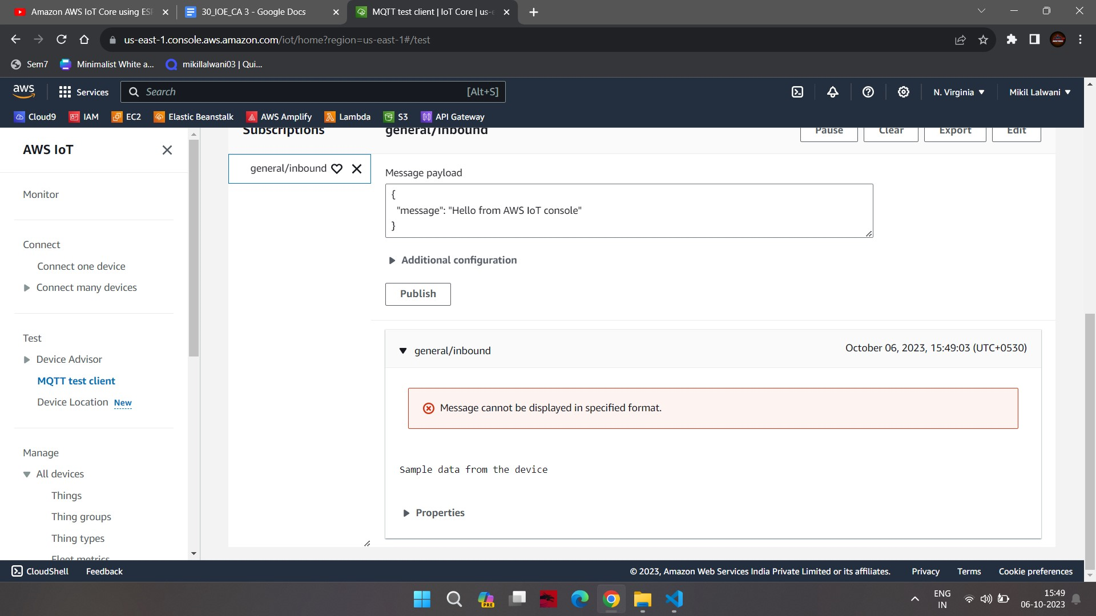**Step 14:** Then run subscribe.py 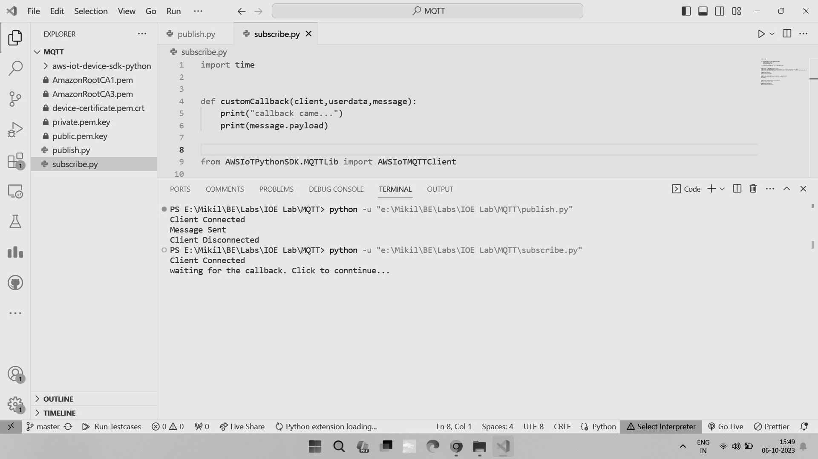

**Step 15:** Go to publish to topic and type general/outbound and click on publish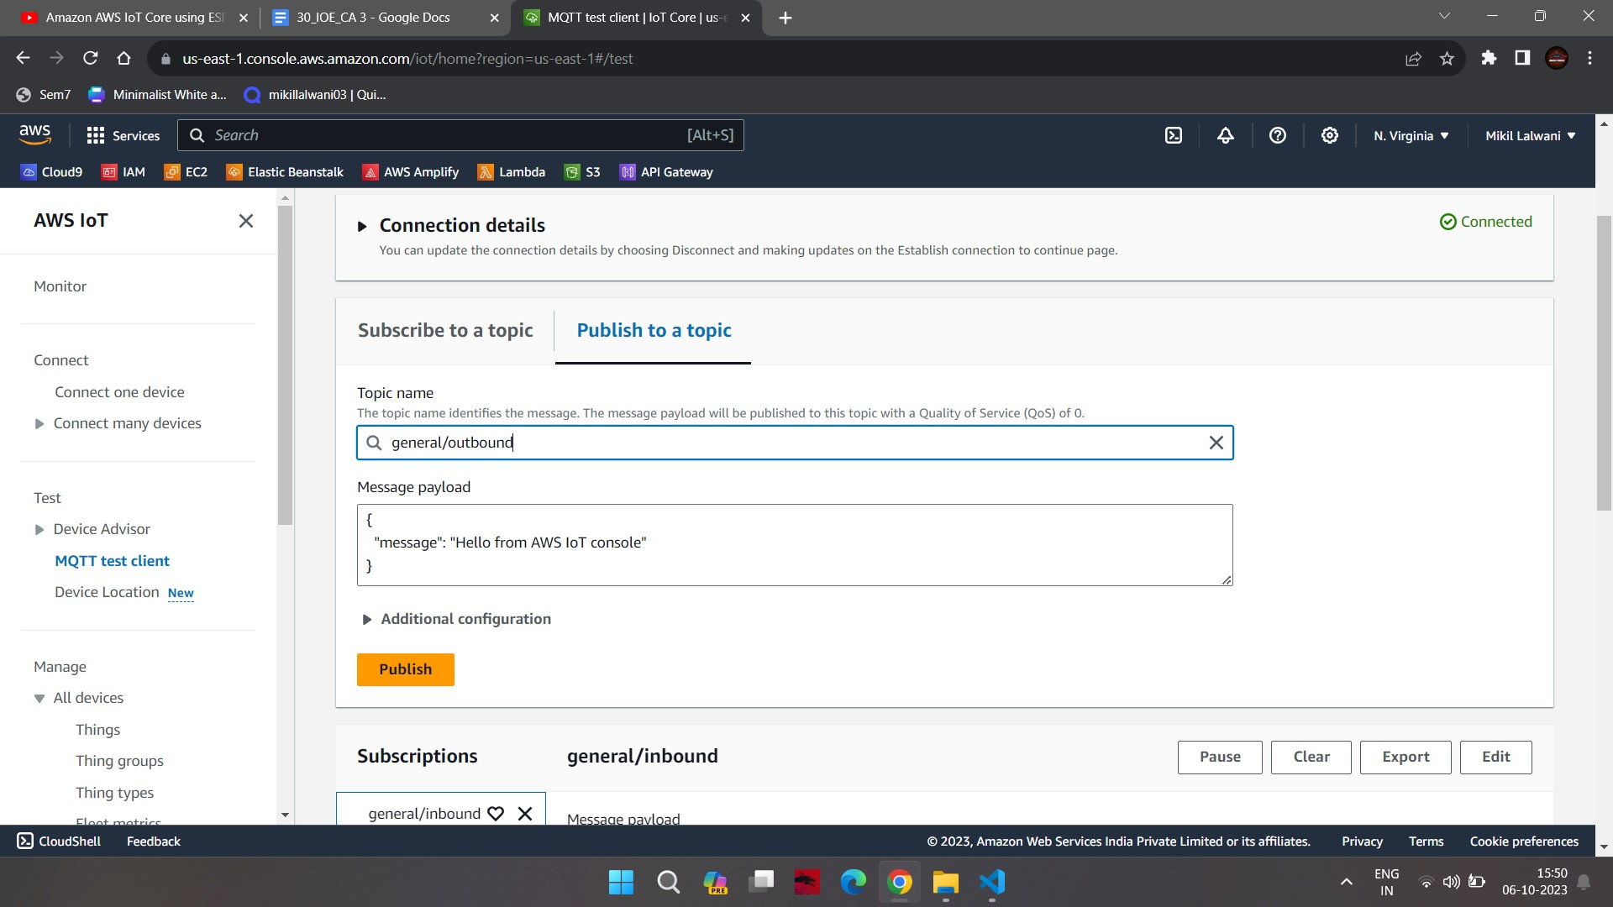

**Step 16:** After clicking on publish go to terminal and you can see the message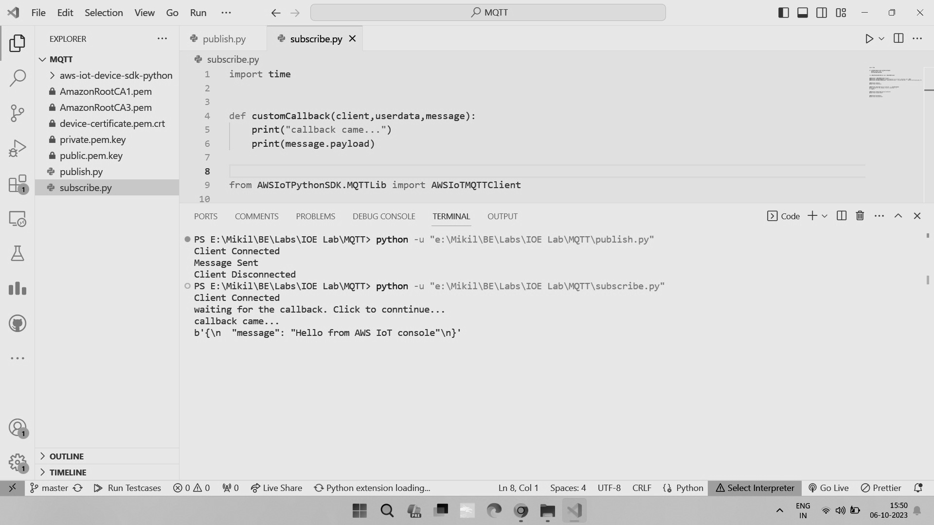

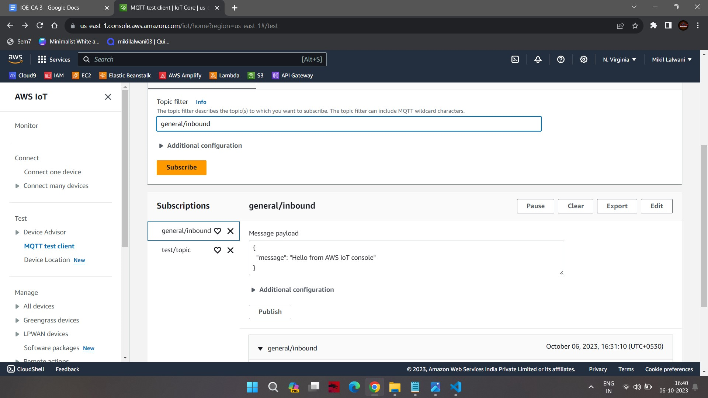

**HTTP:**

**Code**

import requests

import argparse

# define command-line parameters

parser = argparse.ArgumentParser(description="Send messages through an HTTPS connection.")

parser.add_argument('--endpoint', required=True, help="Your AWS IoT data custom endpoint, not including a port. " + "Ex: \"abcdEXAMPLExyz-ats.iot.us-east-1.amazonaws.com\"")

parser.add_argument('--cert', required=True, help="File path to your client certificate, in PEM format.")

parser.add_argument('--key', required=True, help="File path to your private key, in PEM format.")

parser.add_argument('--topic', required=True, default="test/topic", help="Topic to publish messages to.")

parser.add_argument('--message', default="Hello World!", help="Message to publish. " + "Specify empty string to publish nothing.")

# parse and load command-line parameter values

args = parser.parse_args()

# create and format values for HTTPS request

publish_url = 'https://' + args.endpoint + ':8443/topics/' + args.topic + '?qos=1'

publish_msg = args.message.encode('utf-8')

# make request

publish = requests.request('POST',

publish_url,

data=publish_msg,

cert=[args.cert, args.key])

# print results

print("Response status: ", str(publish.status_code))

if publish.status_code == 200:

print("Response body:", publish.text)

**Step 1:** Change your endpoint and device certificate and private key file name in the below code

**python http_code.py --endpoint "a1ek9vqv3jnbud-ats.iot.us-east-1.amazonaws.com" --cert "./device-certificate.pem.crt" --key "./private.pem.key" --topic "test/topic" --message "Test37"**

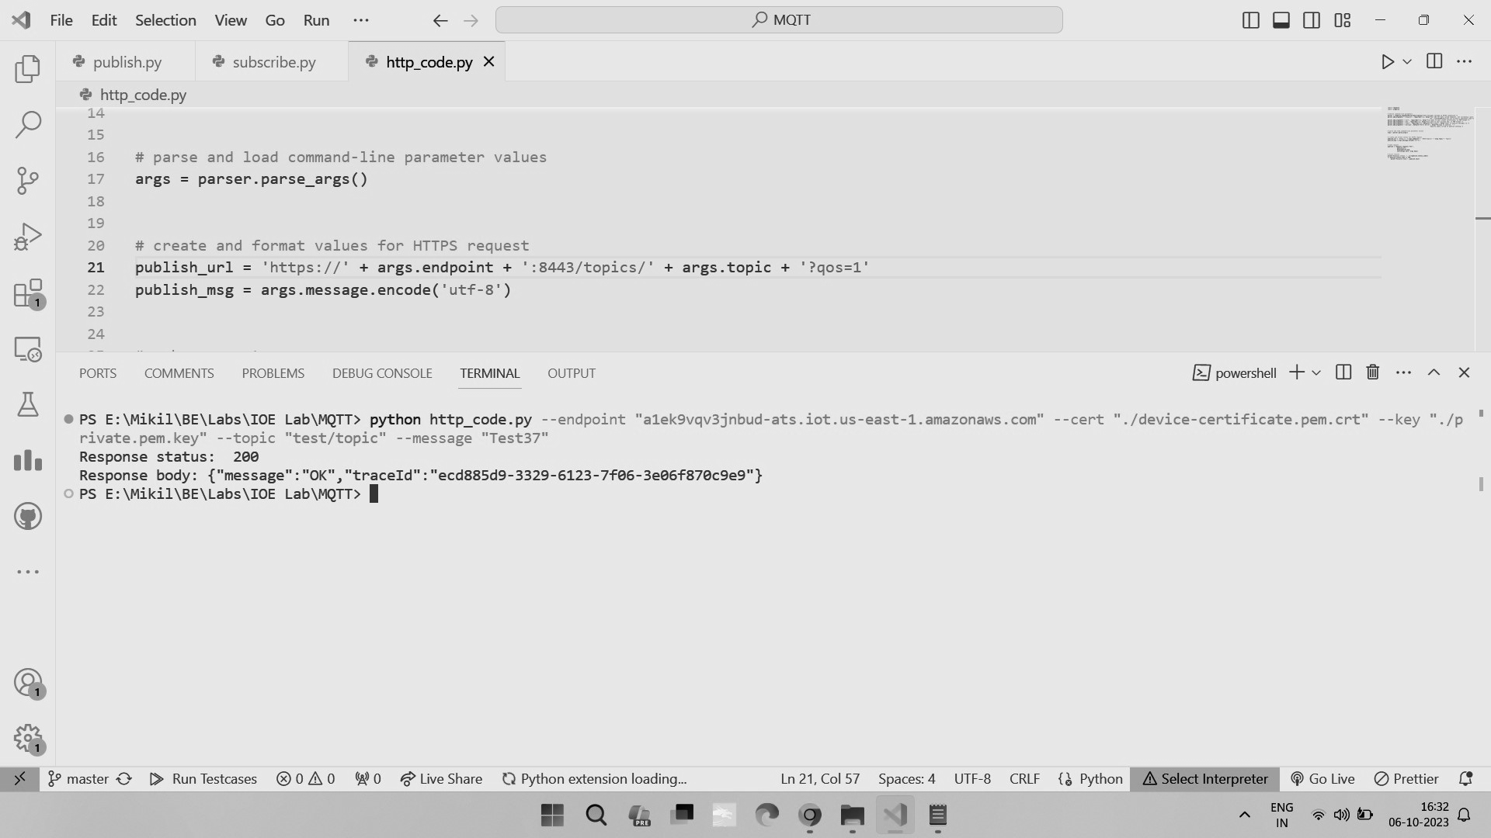

**Step 2:** Check message received by subscribing to the topic 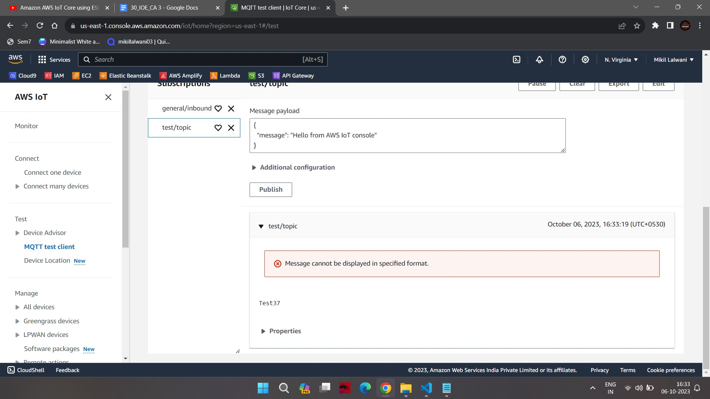

**Step 3:** On dashboard you can see both protocols has been implemented successfully